LONDON’S GLOBAL UNIVERSITY



UCL-IG37 Data Safe Haven Risk Assessment Process

- Document Information
Document Name | UCL-IG37 Data Safe Haven Risk Assessment Process
Author | Bridget Kenyon and Alice Garrett
Issue Date | 09/06/2021
Categorisation | Normal
Approved By | Data Safe Haven Operational Management Group
Next review | Three years

- Document History
Version | Date | Summary of change
0.1 | 24/03/2014 | UCL Standard Process updated by A Garrett
1.0 | 06/05/2014 | Approved by T Peacock
1.1 | 28/05/2014 | Updated section 3.g. following ISO 27001 Stage 1 Audit
1.2 | 03/12/2015 | Updated overview to include SCP trigger for Risk Assessment. Formalised timing and Risk Assessment Group membership.
1.3 | 04/04/2017 | Review by Jack Hindley
1.4 | 11/04/2018 | Reviewed by Operational Management Group
2.0 | 06/06/2018 | Approved by Operational Management Group
2.1 | 16/05/2021 | Merged Quick Risk Assessment and review to clarify and include examples. Added responsibility for, and annual review of intolerable risks
3.0 | 09/06/2021 | Approved by Chair of IG Steering Group

Risk Assessment Overview

This full risk assessment process is used to assess threats and risks in detail, and identify and document the measures (controls) which are to be used by the organisation. This will enable the organisation to manage information security risk, to ensure that the Data Safe Haven is suitably secure.

Risk Assessments will be carried out at least once a term, at least two weeks before the IG Steering Group meeting where the results will be presented, or as a result of:
- feedback from the risk treatment process
- a serious incident
- a change where there is a potential impact on information security

The risk assessments will be undertaken by the Risk Assessment Group whose membership will be IG Lead, Data Safe Haven Service Operational Manager, Data Safe Haven Service Owner and Head of Information Security.

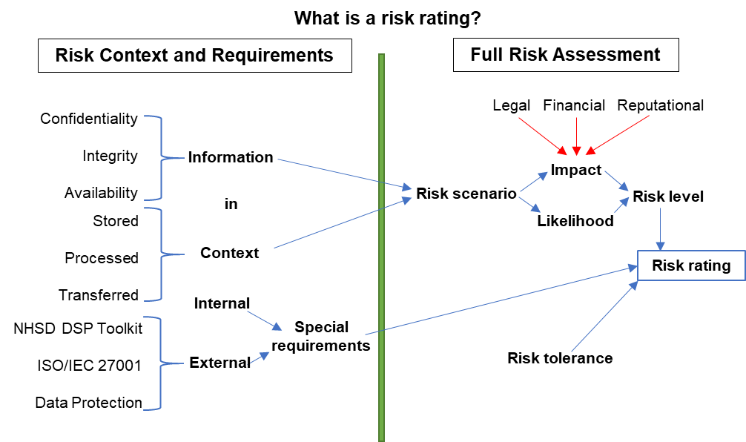

Risk context and requirements

Information classification
The UCL Information Management Policy determines the classification of information for the University as a whole. The following table represents the UCL classification of information for ‘confidentiality’, observed from the Information Management Policy.

Classification of data involved | Highly Confidential | Confidential | Public
Description of data | Special category under GDPR, or information that is restricted by specific legislation, regulation or contract that would have a high impact in the event of unauthorised disclosure | Personal data or information that is restricted by legislation, regulation or contract that would not have a high impact in the event of unauthorised disclosure | Information that is intended to be for anyone to access freely

Information Security Requirements
 | Low/Medium/High
Confidentiality | High
Integrity | High
Availability | Medium

Information Security Continuity Requirements in Adverse Situations
In the event of an adverse situation, continuity of information security is managed through the Critical Incident Management Process, which includes emergency change control. The Data Safe Haven Service Management Plan includes information security aspects of continuity scenarios, including a test plan, and details the people, processes and technology to address maintenance of information security.

During an adverse situation, the following information security requirements apply. Further details of how specific risk events would be managed and the relevant preventative, detective and corrective controls can be found in the Risk Treatment Plan.

 | Low/Medium/High
Confidentiality | High
Integrity | High
Availability | Low

Internal Requirements
What internal policies, procedures and other requirements apply to the security of the information being handled by the organisation?
The organisation is subject to the UCL Information Governance (IG) Framework which contains policies and IG guidance approved by the IG Steering Group and Senior Information Risk Owner (SIRO). It is also subject to the guidelines and policies set at a corporate level such as the UCL Data Protection Policy and Information Security Policy.

External Requirements
What external legislation, contracts and other requirements apply to the security of the information being handled by the organisation?
The organisation is subject to individual data sharing and non-disclosure agreements associated with specific information assets. Where receiving information from NHS Digital, for example, the organisation is subject to NHS Digital’s contractual requirements.

Where research studies have applied for exemption from the common law duty of confidentiality under Section 251 of the 2006 NHS Act, they are subject to all of the requirements associated with a Data Security & Protection Toolkit.

Storage
How will information be stored by the organisation?
It is recommended that highly confidential research information is stored within the Data Safe Haven except where that information is handled in an alternative technical environment with equivalent security.
Level of risk to the information: To be determined through the full risk assessment (section 4, below)

Processing
How will information be processed by the organisation?
It is recommended that highly confidential research information is processed within the Data Safe Haven except where that information is handled in an alternative technical environment with equivalent security.
See information above regarding the Data Safe Haven.
Level of risk to the information: To be determined through the full risk assessment (section 4, below)

Transfers
How will information be transferred by the organisation?
A secure Managed File Transfer service is provided as part of the Data Safe Haven system, making it possible to securely upload information from outside of the UCL network. Data must be transmitted in a manner consistent with relevant Data Sharing or Non-Disclosure agreements. If encrypted, it is essential that the standard meets or exceeds AES 256 bit (the standard required by the Data Security & Protection Toolkit).
Level of risk to the information: To be determined through the full risk assessment (section 4, below)

Risk Assessment Methodology
This section is documented using the UCL Data Safe Haven Risk Assessment.

A summary of expected actions:

- When the risk assessment is carried out, the Risk Assessment Group shall summarise any recent or planned changes introduced to the organisation and the operational environment, any incidents and any external developments since the last risk assessment meeting to identify any changes that would affect the impact and likelihood of a threat materialising.
- Current risks levels will then be recorded in the Risk Assessment using the UCL Information Security Group ratings for impact and likelihood (see footnote).
- The Risk Assessment Group will then consider if there are any controls that would mitigate against the current risk or if any existing controls could be modified to mitigate further, weighing the expected benefit in each case with the feasibility.
- The outcome of the assessment will be recorded in the Risk Assessment Review template.

Organisational System Characterisation

The following information about the current environment within scope of the ISMS must be collected:

General | IT related
- Organisational objectives  - Kinds of information  - Persons within the organisation, whether users or support staff  - The value or importance of information assets to the organisation  - Information classification  - Legal, regulatory and contractual requirements  - Physical security environment (e.g. access controls) | - Hardware  - Software  - System interfaces (e.g. internal and external connectivity)  - Information storage protection that safeguards system and data confidentiality, integrity, and availability  - Flow of information pertaining to the IT system (e.g. system interfaces, system input and output flowchart)

Risk Scenario Identification (Risk Areas)

The aim of this section is to identify possible risk scenarios associated with the service.
The UCL Information Security Group will define a standard set of risk scenarios which the ISMS will align with.

Example Risk Scenarios (what could go wrong, how it could happen):
User deliberately or accidentally leaks information
- a user shows something on their screen to a colleague who is not authorised to access the data
- a user continues to have access after leaving the research team because their access has not been rescinded
- a user exports the wrong set of data or sends data to the wrong recipient
User accidentally or deliberately damages information
- a user runs a query in a database which deletes records inadvertently and goes unnoticed for a period of time
- a user accidentally copies data from the wrong source into a spreadsheet
Premises Break-in
- an opportunist notices that during a fire drill, the doors are propped open at the data centre
- a break-in at a research team’s office provides access to their computers
Acts of God, Vandals and Terrorists
- problems with drainage cause flooding
Theft or loss of mobile devices
- a user’s mobile phone is stolen, unlocked and used to generate a login token
Software failure
- a software upgrade creates a vulnerability that is not reported or patched in time
- a mis-configuration allows unauthorised access
Hardware or "infrastructure" Failures
- cooling system failure
- server component failure
Power Failure
- problems with the the supply of power
Internet/Communications Failure
- JANET is mismanaged and internet access fails
- a change to the UCL network prevents access
Hacking
- a system admin’s password vault is hacked
Denial of Service
- someone orchestrates a DDoS on the Data Safe Haven

Likelihood Determination
To derive an overall likelihood rating that indicates the probability that a potential vulnerability may be exercised within the construct of the associated threat environment, the following governing factors will be considered by the UCL Information Security Group, and used by the ISMS in considering the likelihood:

- Threat-source motivation and capability
- Nature of the vulnerability
- Existence and effectiveness of current controls.

The likelihood that a potential vulnerability could be exercised by a given threat-source can be described as very high, high, medium, low, or very low.

Likelihood Rating Guidelines
Very high | This risk is occurring at present and is likely to continue to do so over the next 2 years.
High | This risk is likely to occur during the next 2 years (>50% probability)
Medium | This risk could occur during the next 2 years (20% - 50% probability)
Low | This risk is unlikely to occur during the next 2 years (<20% probability)
Very low | This risk is extremely unlikely to occur during the next 2 years (<5%)

Impact Analysis
The goal of this step is to determine the adverse impact resulting from a risk scenario (where a threat and vulnerability combine). Impact can be immediate or delayed. The UCL Information Security Group will determine impact factors which the ISMS will align with.

Examples of impact:
- Financial loss
- Loss of reputation
- Breaches of legal, regulatory or contractual requirements
Impact Rating Guidelines (threat = t, opportunity = o)
Very high | - Financial loss (t) / gain (o) > £15m  - Reputational damage (t) / enhancement (o) having significant influence on future student recruitment, research activity, strategically important business partners, funding bodies, institutional review bodies  - Widespread loss (t) / enhancement (o) of academic programme delivery/business critical systems  - Death or multiple life threatening injuries (t)
High | - Financial loss (t) / gain (o) between £7m and £15m  - Reputational damage (t) / enhancement (o) having material impact on future student recruitment, research activity, existing business partners/external stakeholders  - Major and/or long term disruption (t) / enhancement (o) to academic programme delivery/business critical systems  - Life threatening injury or multiple serious injuries hospitalization (t)
Medium | - Financial loss (t) / gain (o) between £2m and £7m  - Reputational damage (t) / enhancement (o) affecting local community, existing students, potential staff  - Material and/or medium term disruption (t) / enhancement (o) to academic programme delivery/business critical systems  - Serious injury hospitalization or multiple injuries requiring first aid (t)
Low | - Financial loss (t) / gain (o) < £2m  - Reputational damage (t) / enhancement (o) affecting existing staff  - Minor and/or short term disruption (t) / enhancement (o) to academic programme delivery/business critical systems  - Injuries or ailments not requiring medical treatment (t)
Very low | - Financial loss (t) / gain (o) < £250k  - Minimal disruption (t) / enhancement (o) to academic programme delivery/business critical systems

Current Controls
Control: The aim of this step is to analyse the controls that have been implemented, or are planned for implementation, by the organisation to minimise or eliminate the likelihood of a threat’s exercising of a vulnerability.

A control is any measure or action that modifies risk. Controls include any policy, procedure, practice, process, technology, technique, method, or device that modifies or manages risk. Risk treatments become controls, or modify existing controls, once they have been implemented.

The controls analysed may include technical, operational, and management controls.
- Technical controls used for the service (e.g. built-in or add-on security product that supports identification and authentication, discretionary or mandatory access control, audit, residual information protection, encryption methods)
- Operational controls used for the service (e.g. personnel security, backup, contingency, and resumption and recovery operations, system maintenance, off-site storage, user account establishment and deletion procedures, controls for segregation of user functions, such as privileged user access versus standard user access)
- Management controls used for the service (e.g. rules of behavior, security planning)

Proposed Additional Controls
During this step of the process, further controls that could mitigate or eliminate the identified risks, as appropriate to the organisation’s operations, are identified. The aim of the recommended controls is to reduce the level of risk to the service and its data to an Manageable level. The following factors should be considered in recommending controls and alternative solutions to minimise or eliminate identified risks:
- Effectiveness of recommended options (e.g., system compatibility)
- Legislation and regulation
- Organisational policy
- Operational impact
- Safety and reliability.
To determine which controls are required and appropriate, a cost-benefit analysis should be performed for the proposed recommended controls, to demonstrate that the costs of implementing the controls can be justified by the reduction in the level of risk.

Risk Determination
The UCL rating of risks will be drawn up by the UCL Information Security Group and will be represented below. The original document can be found (see footnote).

The goal of this step is to assess the level of risk to the service. The determination of risk for a particular threat/vulnerability pair can be expressed as a function of:
- The likelihood of a given threat-source’s attempting to exercise a given vulnerability
- The magnitude of the impact should a threat-source successfully exercise the vulnerability
- The adequacy of planned or existing security controls for reducing or eliminating risk

 |  | Likelihood
 |  | Very low | Low | Medium | High | Very high
Impact | Very low | Manageable | Manageable | Manageable | Manageable | Manageable
 | Low | Manageable | Manageable | Manageable | Manageable | Manageable
 | Medium | Manageable | Manageable | Manageable | Severe | Severe
 | High | Manageable | Manageable | Severe | Intolerable | Intolerable
 | Very high | Manageable | Severe | Intolerable | Intolerable | Intolerable

Risk status definitions:
- Intolerable: The University feels most concerned about – or experiences severe discomfort at – carrying this risk for one or more of the following reasons; there are insufficient controls in place to address the cause or source of risk; controls are considered insubstantial or ineffective; controls are being implemented but are not yet in place. If this risk were to materialise, the situation could be irrecoverable in terms of the University’s reputational/financial wellbeing and/or service continuity. A Risk Treatment Plan should be produced or any existing Risk Treatment Plan should be reviewed.
- Severe: The University feels concerned about carrying this risk. There are few controls in place, which are considered substantial and/or effective and address the cause of the risk. The consequences of the risk materialising, though severe, can be managed to some extent via contingency plans. A Risk Treatment Plan should be produced or any existing Risk Treatment Plan should be reviewed.
- Manageable: The University is prepared to accept this level of risk. The risk is considered to be small and there are sufficient controls in place, which address substantially and/or effectively the cause of the risk. The consequences of the risk materialising can be managed via contingency plans. Summary details of the key controls and early warning indicators should be recorded. The risk should be allocated to the relevant personnel to monitor.

The Senior Information Risk Owner (SIRO) is responsible for deciding whether to accept residual risks where the level is determined as either Severe or Intolerable. An example of this would be in the event of an unlikely event leading to some catastrophic consequence (e.g. a terrorist event) or if there was some very strong organisational justification for doing so.

Results documented, date planned for next review.
Once the risk assessment has been completed (threat-sources and vulnerabilities identified, risks assessed, and recommended controls provided), the results should be reported to the Information Governance Steering Group who must accept and own the maintenance of the risk assessment and any associated improvement plans.

It is important to set the date for the next review; this is to allow for continual improvement and notification of changes.

In cases where a Severe or Intolerable risk has been accepted, acceptance of the risk must be reviewed by the SIRO annually or in the light of any incident or change relating to that risk.

https://liveuclac.sharepoint.com/sites/ISD.InformationSecurityGroup/Team%20Documents/Policy/Information-Management-Policy-IRGG-20170912.pdf
Includes creation and destruction
Replicated to a new location
https://liveuclac.sharepoint.com/sites/ISD.InformationSecurityGroup/Team%20Documents/Risk/Information-Risk-Assessment-Likelihood-and-Impact-Ratings-v1-01.pdf
https://www.ucl.ac.uk/informationsecurity/docs/Information-Risk-Assessment-Likelihood-and-Impact-Ratings-v1-01.pdf

